Human Services Cluster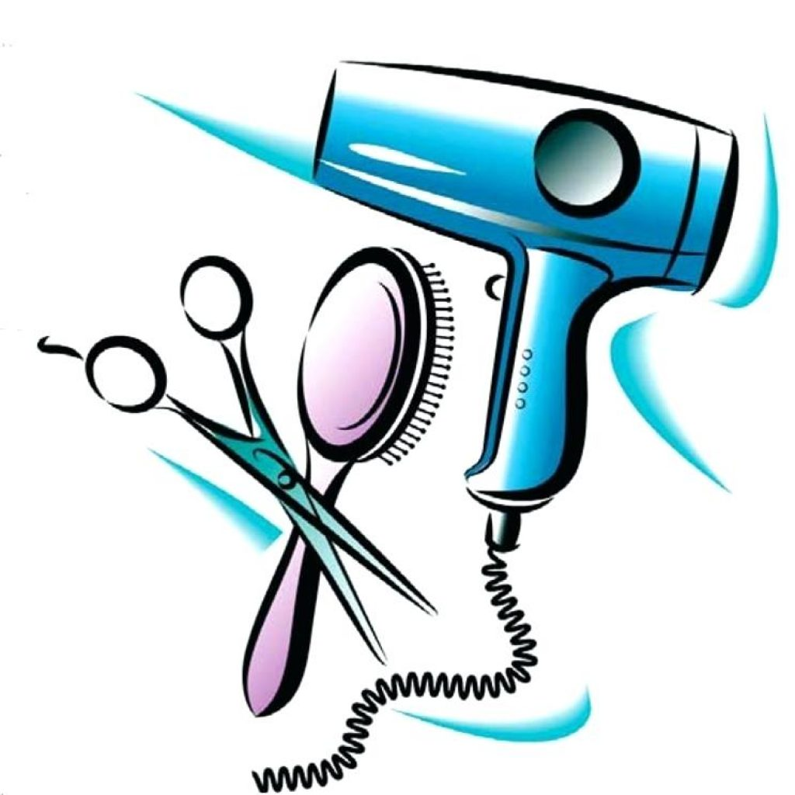
Introduction to Personal Care Services
Course Description:
This course introduces both fundamental theory and practices of the personal care professions
including nail technicians, estheticians, barbers, and cosmetologists. Emphasis will be placed on
professional practices and safety. Areas addressed in this course include: state rules and
regulations, professional image, bacteriology, decontamination and infection control, chemistry
fundamentals, safety, Hazardous Duty Standards Act compliance, and anatomy and physiology.
Students will experience basic hands on skills in each area to help them determine the pathway they are most interested in pursuing. By completing courses in the personal care services pathways, students can potentially earn credit toward the hours required by the Georgia State Board of Barbering and/or Cosmetology or hours toward their license as an esthetician or nail technician.

